Sensing4U Sensor Management System

- Introduction
The Sensing4U sensor management system was developed as a minimum viable product (MVP) designed to manage and process sensor data sets for customers across various industries. This application allows users to load multiple sensor files, view the data at a glance, perform calculations, and visualize the results. Its primary goal is to centralize diverse sensor data and facilitate easy and convenient data management.

- SDLC
The development of the Sensing4U Sensor Management System followed a hybrid (iterative) development model, combining the structured planning of the Waterfall model with the flexibility and rapid feedback cycle of Agile methodology. The project began with requirement analysis and planning, followed by meetings with the client (lecturer) to clarify and refine the requirements based on feedback. Using this feedback, the system design and class structure were created, reviewed, and improved through iterative revisions. During the implementation phase, each feature was developed and tested in small increments, allowing previous components to be refined or adjusted as needed. This approach enabled continuous feedback integration, improved overall quality, and ensured that issues identified during development were resolved quickly, leading to a more complete and reliable application.

- Requirements

- Load sensor data from binary (.bin) files.
- Display loaded data in a grid view.
- Navigate between loaded files using Previous and Next buttons.
- Sort sensor data to prepare for searching.
- Perform a binary search using user-entered values.
- Calculate and display the average value of the dataset.
- Apply color mapping based on user-defined upper and lower bounds:
-Red: Above the upper bound
-Green: Within range
-Blue: Below the lower bound
- Save the dataset back into a binary (.bin) file.
- Display informational messages and error messages to guide user interactions.
- Generate external documentation (project report for client review).
- Maintain internal documentation (XML code comments and summaries) to support future maintenance and development.

- Features Implemented and guide

Feature | Guide
Open File | Click Open File to open a file explorer and select a .bin file to load sensor data into the grid view.
Save File | Click Save File to open a file explorer and choose a location and filename to save the current dataset.
Next/Previous Navigation | Click Next or Previous to switch between loaded datasets and display the selected dataset in the grid.
Loaded File List | Shows all previously loaded files in order for easy tracking and navigation.
User Bounds | Enter lower and upper bounds to define the value range for color comparison in the grid.
Color Mapping | After entering bounds, click Data Indicator to apply colors: Red = above, Green = normal, Blue = below.
sort | When a search value is entered and Search is clicked, the current dataset is automatically sorted before searching.
Search | Enter a value and click Search to highlight the matching record in the grid.
Average | Click Average to calculate and display the average value of the current dataset.
Reset | When a new file is loaded, all UI inputs and previous results (search, colors, average) are reset automatically.
Message Box | Success and error messages are displayed depending on the action or invalid input.

- Commit history
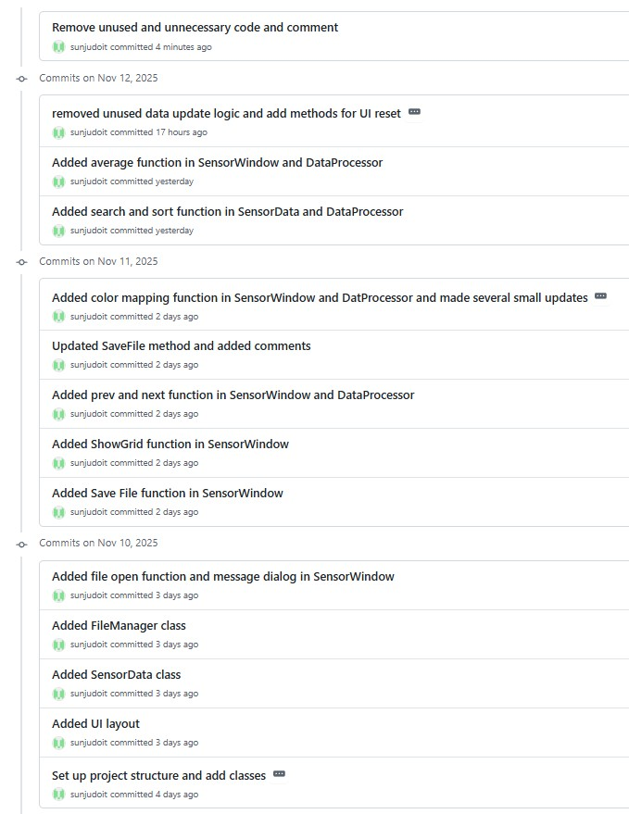

- Possible Extensions
- Support additional file formats such as CSV or JSON.
- Add functionality to modify or edit individual sensor data values.
- Allow users to view and manage loaded datasets by selecting and deleting items from the file list.
- Provide a comparison view that displays two datasets side-by-side in the grid for visual comparison.

- Limitations & Restrictions
  - Only the .bin file format is supported for loading and saving data.
  - Individual sensor data points cannot be edited or deleted.
  - Dataset navigation is only available through the Previous/Next buttons, not by clicking items in the list.
  - The interface can display only one dataset at a time.

